Technical Assistance support provided by
Agriconsulting Consortium
The European Union’s Regional Programmes Neighbourhood South

This project is funded by
The European Union

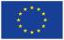
Lebanon Country Report
February - March 2013

ENPI/2012/308-787
ENPI CLIMA-SOUTH
Support to Climate Change Mitigation and Adaptation in the ENPI South Region

The contents of this publication are the sole responsibility of Agriconsulting and can in no way be taken to reflect the views of the European Commission. April 2013
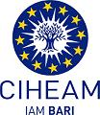

Table of content
List of Acronyms 2
1. Introduction 3
2. The GHG Assessment Policy Assessment up-date in Lebanon 6
2.1 The low carbon development issues 6
2.2 GHG stakeholders consultations 7
2.3 GHG performance to date 8
2.4 Mitigation assessment and mitigation options 9
2.5 Climate Change Finance 10
2.7 Maping and synthesis of the results obtained 11
3.Adaptation/Climate Resilience in Lebanon 13
3.1Climatedata modeling 13
3.2 Socio-economic data related to climate change 15
3.3 Vulnerability assessment 16
3.4 Adaptation to climate change 17
3.5 Access to finance for adaptation to climate change 18
3.6 Stakerholders awareness to adaptation to climate change 18
3.7 Mapping and synthesis of results obtained 19
3.8 Targets for improvement of the current situation 20
4.The communication and visibility issue 22
4.1Findings for Lebanon 22
4.2Targeted audience in Lebanon 23
5. Conclusions 24

Annex1: List of interviewed stakeholders
Annex 2: Documentation collected& reviewed
Annex 3: List of on-going projects
Annex 4: List of possible activities

List of Acronyms

AUB | American University of Beirut
CDM | Clean Development Mechanism
CER | Certified Emission Reduction
CC | Climate Change
CEDRO | Country Energy Efficiency and Renewable Energy Demonstration Project
CME | Coordinating and ManagingEntity
COP | Conference of the Parties
EC | European Commission
ENP | European Neigbourhood Policy
ENPI | European Neigbourhood Policy Instrument
ERU | Emission Reduction Unit
ERs | Emission reductions
ESCWA | Economic and Social Commission of Western Asia
ETS | Emission Trading System (Scheme)
EU | European Union
EU-ETS | European Union Emission Trading System
GEF | Global Environment Facility
GHG | Greenhouse Gases
IPCC | Intergovernmental Panel on Climate Change
JI | Joint Implementation
LCDS | Low Carbon Development Strategy
LCEC | Lebanon Center for Energy Conservation
LEDS | Low Emission Development Strategy
LMD | Lebanese Meteorological Department
LULUCF | land use, land use change and forestry
MEDSTAT | (Programme on) Mediterranean Statistics
MoEnv | Ministry of Environment
MoE& WR | Ministry of Energy and Water Resources
MRV | Monitoring, Reporting, Verification
MtCO₂eq | Million tons of CO₂ equivalent
NAMA | Nationally Appropriate Mitigation Action
NMM | New Market Mechanism
PSC | Project Steering Committee
P-CDM | Progammatic CDM (Program of activities)
PEE | Energy and Environment Programme
RIP | Regional Indicative Programme
SCM | Sectoral Crediting Mechanism
SEIS | Shared Environmental Information System
SIDS | Small Island Developing States
STM | Sectoral Trading Mechanism
SWIM | Sustainable Water Integrated Management
TA | Technical Assistance
tCO2eq | Tons of CO₂ equivalent
ToRs | Terms of Reference
TNC | Third national communication
UNDP | United Nations Development Programme
UNFCCC | United Nations Framework Convention on Climate Change

Introduction
The ENPI ClimA-South project is at the beginning of the inception phase. A first mission was organized in Beirut (February 19th -March 1st2013) with the entire team to build and strengthen the project team, review the methodology and the overall work plan of the project --including the indicators for monitoring and evaluation of the project performance in addition to conducting the 1st country visits to meet with key stakeholders.The four key experts met at the newly established, and fully furnished office in Beirut (see pictures below).
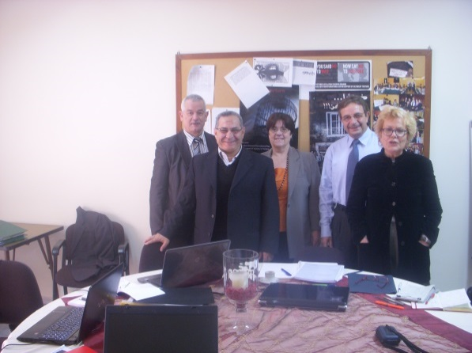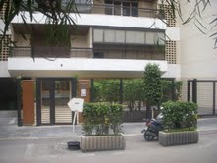

Legend: ENPI Project Office building and project team , February 2013
- Identification process of field of activities and methodology
This meeting provided the opportunity to review the methodology of activities identification process and in particular to work on the following issues which were further refined for the Monitoring and Evaluation purposes:
- Review of the various work programmes and their interrelations to highlight cross cutting needs: climate change negotiations, climate change finance and communication, all three directly connected to the 2 core programmes on ‘mitigation/low carbon development’ and ‘adaptation/resilience to climate change’.
- Questionnaires to obtain information from stakeholders, shaped on the revised formulation of the workprogrammes and clarifications about the ‘spider graph’ monitoring tool.
The team of Key Experts now update and expand every country profiles during this inception phase on the basis of the most recent documents and reports in consultation with stakeholders interviewed during the fact finding missions. It is used to provide a starting point for the identification tool as described in page 7-8.

Identification of activities / Monitoring tool

The ENPI CLIMA-South is implemented in a dynamic region, with rapidly changing social and political environments. At the same time, climate change is at a critical stage of the international negotiations in which new developments may be expected. Flexibility is therefore of the utmost importance and an approach is needed that can be rapidly adapted on the basis of the changing needs and moving opportunities. This situation was taken into account with the development of a simple, flexible and participatory tool allowing the visualization of issues to agree on means and ways to address them.

The assessment tool used for this project is based on Key Experts’ analysis of the situation described in climate change relevant documentation and the results obtained during interviews and discussions using a set of questionnaires prepared on mitigation, adaptation and communication related issues (see column 1 of each Table).The current situation of a country is assessed and scored from ‘1’ to 5’ indicating that the country’s situation with respect to that particular intervention area is completely satisfactory (where capacities equal needs).

The results obtained are converted in a visual representation of ‘spider chart’; several possible intervention areas are charted on the spokes of the diagram. The number of spokes can be increased and more intervention areas can be added according to questions asked. The Key Expert Adaptation for example has developed a specific one with more adaptation parameters. This method can be best illustrated using an example of the application of the tool as in the figure below.
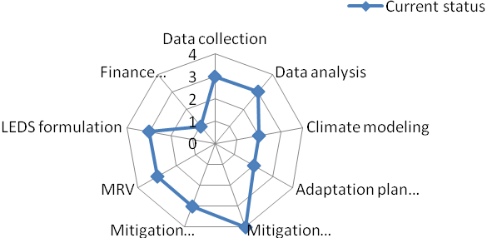
Figure 1.Example of an assessment of climate change capacities
In this example, the country is doing very well on mitigation option identification but poor on climate modeling and adaptation plan formulation and very poor on carbon finance mechanisms. This suggests a direction for priority interventions. The idea is to ‘stretch the web’, in order to smoothen out the indentures in the graph through possible interventions.
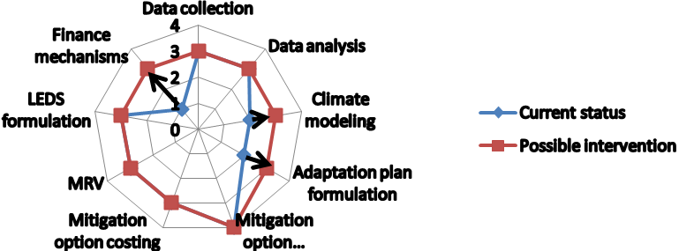
Fig 2:Example of a current status assessment of climate change capacities versus targets

Schematically, this process involves the following steps:
- Pre-condition:
The national counterpart is clearly identified to discuss it
- Assessment of needs should be based on:
Views of national government stakeholders
Views of expert community
Objective indicators (when possible)
- The assessment of the current status should be based on the same sources of information
Views of national government stakeholders
Views of expert community
Objective indicators (when possible)
- Other donor interventions are important to consider. Important aspects that should be reflected in the analysis are
To what extent can other donors’ efforts bridge the gap between needs & currentstatus
Timeline – how long will it take to achieve these gap-eliminations?
How can we monitor progress?
- Discussion with national counterparts
Initial outcome of the analysis of needs vs. status vs. ongoing donor efforts: suggested
priority gaps to be addressed
Feedback and agreement on priority needs.
This process can be repeated from time to time to measure progress. The tool can also be applied several times to zoom in on various topics. Interventions are formulated against needs as assessed. Eliminating the indentures in the form then means eliminating the worst gaps between the current situation and the needs of the country (or region). Major donors’ interventionson climate change can be placed to identify which areas may already be covered, or where coordination of efforts would be needed.This analysis, and the ‘webs’ created is an excellent tool to support dialogue and communication with other donors and coordination of efforts.While the tool and its use is intuitively clear, constructive dialogue is necessary to make it perform well.

2. The GHG Assessment Policy Assessment up-date in Lebanon

2.1 The low carbon development issues
As stated in the methodology, “the ENP South countries differ in their readiness and willingness to take actions on mitigation/low carbon development. This may be clear from the statistics on registered CDM projects and whether or not they have proposed NAMAs included in the UNFCCC Secretariat’s Compilation of information on nationally appropriate mitigation actions to be implemented by Parties not included in Annex I to the Convention. Table (1) below shows ENPI Countries, Israel, Jordan and Morocco as the more active; Egypt and Tunisia as ‘in between’ and Algeria, Libya, Palestine and Syria as the relatively least active, as well as Lebanon with 7 CDM projects recently registered but with no submitted NAMAs”. Table (1) below summarizes the situation.
Table (1) CDM projects & submitted NAMAs in ENPI South countries Lebanon
Country | No. registered CDM projects | NAMA submission | Country | No. registered CDM projects | NAMA submission
Algeria | 0 | Yes,  not concrete | Libya | 1 | No
Egypt | 11 | No | Morocco | 8 | Yes, specific
Israel | 25 | Yes, specific | Palestine | 0 | No
Jordan | 4 | Yes, specific | Syria | 3 | No
Lebanon | 7 | No | Tunisia | 2 | Yes, specific

The GHG situation is described in Tables (2) belowtaken from the proposed methodology document.
Table (2): GHG and mitigation options in Lebanon
GHG emissions (net) | 1994: 15.9 MtCO₂eq  2000: 18.5 MtCO₂eq | GHG emission growth rate: 2.8% | (1994-2000)
Main GHG emitting sectors | Energy (75%), industrial processes (10%), Waste (9%). All data are for 2000. Percentages are based on total net emissions.
Special national circumstances | Lebanon has one of the highest population densities in the world ranking 11th with 391 persons/km², and the city of Beirut has the highest density among all governorates with 21,938 persons/km²
Mitigation | Mitigation options have been identified for all the main sectors. The most potential is in the energy industries (the largest source), especially through increased uptake of renewable energy and fuel switches in power generation (from oil-fired to gas-fired).

2.2 GHG stakeholders consultations
The expert reviewed the parts relevant to climate change mitigation in the reports and documents on Lebanon such as the Second National Communication, report of EU on the Climate Change Risk Assessment in the Arab countries (Country profile of Lebanon), National Environmental Economic and Development Study for Lebanon (NEEDS), TechnologyNeeds Assessment, and some other relevant documents. A series of interviews through consultative meetings was organised with different stakeholders including the EU delegation in Lebanon, the Ministry of Environment representatives among with the UNFCCC focal point, the Climate Change Coordinating Unit Project (CCCU), the Third National Communication Project (TNC) team. The discussions concluded that there is a need to strengthen the institutional structure of the climate change to be able to address the challenges encountered by the impacts of climate change, also it is of high importance to build the capacity of national experts in conducting the GHG inventory and mitigation assessment and mitigation scenarios modelling and increasing the capability to benefit from the New Market Mechanisms dealing with carbon markets in the context of sustainable development in Lebanon. The envisaged role of the CCCU is to improve climate change governance and meet the challenges that will face Lebanon as a result of climate change through mainstreaming climate change concepts into national and sectoral development plans and to coordinate on-going climate change initiatives that are scattered. To achieve this, the proposed project presents a comprehensive coordination mechanism involving strategic planning, and close and effective communication with national, regional and international partners. In addition, the project will assess the impacts of climate change on the Lebanese economy and thus providing a higher chance for climate change to be placed as a priority on the national agenda. The project will also seek large donor funding to develop and implement a low-carbon and climate resilient development agenda.

Regarding the energy sector which is main source of CO2 emissions in Lebanon, we have interviewed the CEDRO project for renewable energy and energy efficiency and Lebanese Center for Energy Conservation (LCEC) in addition to Lebanese Center for Water Conservation (LCEC) in Ministry of Energy and Water. The discussions demonstrated the increasing role of these centers to implement many useful projects either in renewable energy such as wind farms, solar energy such as PV for household and bioenergy for the rural, also the LCEC is doing a lot of activities to enhance the programs for energy conservation and implementing ambitious projects to deployment of solar water heaters (SWH) and efficient lighting by CFL for buildings and street lighting in addition of conducting energy audit and wind and solar atlas. The LCEC used an innovative approach for attaining sustainability in its future work by starting as a UNDP project followed by turning to be as - government-affiliated NGO, supported by UNDP and other donors, giving it the flexibility in managing its work technically, financially and managerially but under the supervision of the government in the same time.

Regarding the role of academia in addressing the climate change, we met with experts from American University of Beirut (AUB) since they contribute to climate change research , also we discussed how to incorporate the private sector (bankers and insurance companies) into the development process via investing in projects regarding CC risk management and new carbon market mechanisms. On exploring the role of NGOs and civil society in CC we have interviewed the Arab Forum for Environment and Development (AFED) which demonstrates a very powerful image, not as regular NGO but as a Think Tank for Environment and CC, with expertise in communication, environmental studies and reporting on the Arab Region since they have most of the tools needed to conduct a completed work. About the regional cooperation between Lebanon with other Arab countries, interviews were carried out with the experts of ESCWA on their role in addressing CC in the Arab region. They demonstrated many important activities in both CC risk assessment and energy (RE and EE) in Arab Countries. They can play an important role for catalysing the cooperation between the EU south-east Arab countries in that regard.

2.3 GHG performance to date
The assessment through stakeholder consultations was conducted using the web structure described in the Methodology proposed for the project. The results of the interviews, consultations and other references are summarised in tables and illustrated in the figures below. According to the agreed methodology, Table(3) below include a column for each activity/topic, current rating of the status of experience, the status of experience, comment and capacity needs to achieve the project target in the field of low carbon development.
Table (3) Assessment of current GHG inventory preparation process in Lebanon
 | Current Rating | Status | Comment | Capacity Needs
Methodology | 3 | Used Tier 1 | Upgrade to higher tiers needed | Capacity building on GHG data collection
Institutional arrangements | 2 | Data collected by experts | No NIS in place, weak institutional Arrangements | Capacity building on GHG national systems
Data management | 2 | Low level of QA/QC | Need to upgrade level of using QA/QC | Capacity building / GHG data management
National Expertise | 2 | Lack of national experts | Low level of institutional & individual expertise | Capacity building on GHG assessment
GHG Data assessment | 3 | No use of modelling | Data assessment needs upgrading | Capacity development on GHG assessment
GHG Records | 2 | Weak archiving capabilities | Need to have a documentation system | Capacity building on GHG data archiving
Figure (3) Current GHG inventory preparation process assessment versus needs in Lebanon
The consultations with the Head of CCCU, the TNC project manager and the UNFCCC focal point in MoEnv concluded that the overall evaluation of the current status is from low for national expertise, data management, institutional arrangements and documentation to medium for methodology and data assessment. The need to involve Lebanon in a GHG inventory training sessions seems clear.

2.4 Mitigation assessment and mitigation options
The consultations with the head of CCCU, the TNC project manager, the UNFCCC focal point in MoEnv and LCEC & CEDRO from MoE&WR concluded that the overall evaluation of the current status is from very low and low for public awareness, natl. expertise to medium and high in mitigation scenarios and Technology Needs Assessment. The need for Lebanon to participate a regional workshop in mitigation assessment, including ER costing is clear.
Table (4) Current mitigation assessment versus needs for mitigation scenarios development
Mitigation Assessment | Rating | Status | Capacity Needs
Mitigation Scenarios & Policies | 3 | medium level | Needs for CD
Mitigation Options | 2 | low level | Needs for CD
Mitigation Options by sector | 3 | medium level | Progress in technologies needs assessment
Technology Needs Assessment | 4 | High (TNA has been done) | Needs to mainstream into National Planning
National Expertise in Mitigation | 2 | low level | Needs to enhance national expertise
National perception on mitigation options | 1 | very low | Increased public awareness

Figure (4) Current mitigation assessment versus needs for mitigation scenarios development

2.5 Climate Change Finance
The consultations with the head of CCCU, the TNC project manager, the UNFCCC focal point in MoEnv and LCEC & CEDRO from MoE & WR concluded that there are 7CDM projects recently registered and one other project requesting registration, so the overall evaluation of the current status is from very low experience in CO₂ costing, perception of private sector, policy makers & insurance, NAMAs, LEDS, NMM sand MRV to medium experience in CO₂ estimation of emission reductions and CDM. There is a need to organize regional and /or national workshops on these topics to build the capacity of the target groups such as private sector (PS), national experts, policy makers (PM), financial institutions (FI) and Ins.

Table (5) Assessment of Current Status vs. needs for of Financial Mechanisms
Activity/Assessment | Rating | Ref | Comment and Capacity Needs
Estimation of CO₂ ERs | 2 | 5 | Low experience, need to CB
Costing of CO₂ ERs | 1 | 5 | Very low experience, need to CB
Perception of PS, FI& Ins | 1 | 5 | Need for PA and CB for PS, PM &Ins
CDM & P-CDM | 3 | 5 | Medium experience, need to CD
NAMAs | 1 | 5 | Very low experience, need to CB
LEDS formulation | 1 | 5 | Very low experience, need to CB
NMMs | 1 | 5 | Very low experience, need to CB
MRV | 1 | 5 | Very low experience, need to CB
Figure (5) Assessment of Current Status vs. needs for Financial Mechanisms

2.7 Maping and synthesis of the results obtained

Based on consultations with the mentioned stakeholders in Lebanon, the overall assessment of Climate Change mitigationconcluded to the following needs:
- a lack of institutional capacity for data collection & management for CC mitigation;
- low experience in modelling in solid waste, industrial& Agricultural sectors while
- medium experience in data assessment at the sectoral level but not at the national level.
There is also:
- a medium experience in mitigation options identification on some sectoral level but not on national level;
- a very low awareness and experience in NAMAs, LEDS, MRVs identification and formulation and;
- low access to carbon markets.

Table (6) Current Status Assessment of Climate Change Mitigation versus Needs
Focus | Rating | Target | Comments | Needs
Data collection | 2 | 4 | Lack of ins. capacity for data collection and management for CC mitigation | Organizing regional and/or national WS on GHG inventory
Data analysis | 3 | 4 | Medium experience in data assessment on sectoral level | CD in data analysis
Mitigation modelling | 2 | 3 | Low experience in modelling in Solid Waste, Industrial & Agricultural sectors | Organizing regional/ national WS on mitigation  Assessment,
Mitigation options & NAMAs identification | 3 | 4 | Sectoral mitigation options identified, not national | Organizing regional/ national WS on NAMAs identification
Mitigation option costing | 1 | 3 | Very low experience in mitigation costing | Organize regional/ national WS on CO₂ costing,
MRV | 1 | 3 | Lack of MRVs and national and international standards | MRVs, LEDS formulation
LEDS formulation | 1 | 3 | Very low experience in LEDS formulation
Finance mechanisms | 2 | 4 | Low contribution to carbon finance mechanisms | Organize regional/ national WS on finance mechanisms

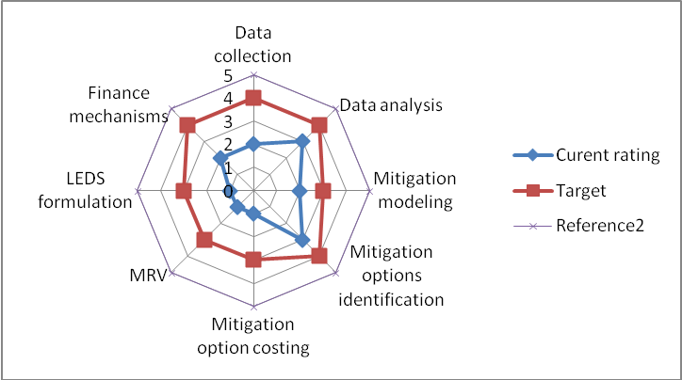
Figure (6) Assessment of climate Change mitigation target versus current rating

We conclude that there is a need to always include participants from Lebanon to regional training workshops on data collection, mitigation options costing, NAMAs identification & LEDS formulation, MRVs and financial mechanisms which need more focus because of its low current rating as illustrated in Figure 6 above.

3. Adaptation/Climate Resilience in Lebanon
The situation concerning adaptation to climate change in Lebanon was summarized in Table (7) produced in the ENPI ClimA South’s methodology.
Table (7) Lebanon
Special national circumstances: | Lebanon has one of the highest population densities in the world ranking 11th with 391 persons/km², and the city of Beirut has the highest density among all governorates with 21,938 persons/km²
Main adaptation challenges: | - Drier and warmer weather will lead to an expected decrease in productivity is expected for most of the crops and fruit trees especially for wheat, tomatoes, cherries, apples and olives.  - Increased peak electricity demand in summer (for cooling purposes), requiring investments in additional power generation capacity.  - Decrease in water availability and increased length of drought periods  - Changes in rainfall patterns, snow coverage, and increases in extreme weather events  - Increased sea water levels, leading to inter alia salt water intrusion.
The analysis of issues related to adaptation to climate change as well as climate resilience in Lebanon is based on the mission to Beirut that enabled us to meet with key stakeholders (see List in Annex 1). The preparation of the mission began with a literature review of key documents related to the CC and CC adaptation in Lebanon. The expert reviewed the parts relevant to climate change adaptation in the reports and documents on Lebanon such as the Second National Communication, report of EU on the Climate Change Risk Assessment in the Arab countries (Country profile of Lebanon), National Environmental Economic and Development Study for Lebanon (NEEDS), TechnologyNeeds Assessment, and some other relevant documents (see Annex 2, Documentation collected and reviewed). A series of consultative meetings were organised with all possible stakeholders.
The analysis of the current situation through the identification of the main elements that characterize it, was conducted through a questionnaire developed in that effect (see Annex 3).Based on the various meetings as well as information collected, we conducted a qualitative assessment of each element of the analysis using the same rating scale that for the mitigation sections.

3.1Climatedata modeling
- Climate observation data and their management

The Lebanese Meteorological Department(LMD) network consists of 18 synoptic stations (around 1 station per 600 km² which is in compliance with World Meteorological Organization standards) as well 18 weather stations. The Lebanese Meteorological Department (the only entity officially recognized by WMO) is for the moment a small unit (physically located within the Beirut airport building) with limited equipment and facilities (bearing in mind the recent post conflict situation); although data were collected since 1921, this service now operates under a Law of 2002 requiring the national department to charge fees for the delivery of climate data which created a real bottle neck; no actual training was ever provided to allow the staff going beyond ‘weather forecast’ to ‘climate change modeling’.

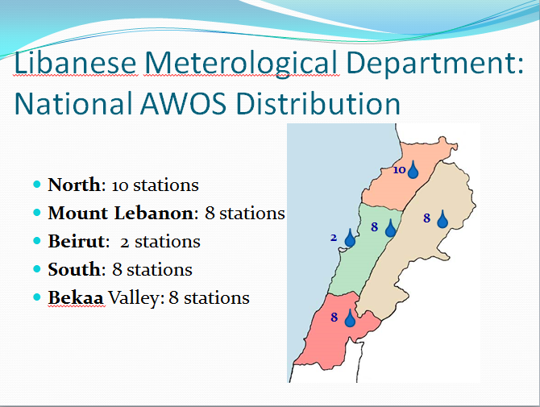The Lebanese Agricultural Research Institute (LARI) has its own network of agro meteorological observations, independently from the LMD, composed by 50 agro-meteorological stations. From a density perspective of this network, the Lebanese meteorological and climate observation capabilities are acceptable.The LMD manages its data in a basic way through an “Access” Microsoft data base.These data are subject to a basic control but would requiremore efficient controls. The LMD data are rarely used; LARI’s data however are used in some applications. The conclusion of the expert is that quality of the data collection; data management and analysis of the LMD and LARI are quite low.
Source: M. WehÏbé LMD Director, Communication to WMO 2013

- Climate change projection / data modeling
Climate change scenarios have been developed for Lebanon through application of the PRECIS (Providing Regional Climate Impacts Studies) regional climate model, developed at the Hadley Centre and based on the HadCM3 GCM. It is applied in a 25 km x 25 km horizontal resolution with the driving emissions scenario A1B. PRECIS was integrated from 1980 throughout the end of the 21st century and the periods considered were the near (2025-2044) and distant future (2080-2098). This climate change simulation has been produced on behalf of the Ministry of Environment and UNDP as part of the SNC, in collaboration with international institutions, without clear coordination with the LMD. As the national authority in the field of meteorology and climate, the LMD has not been involved in the modeling of climate change which constitutes a constraint on the long term sustainability of this activity.From a national sustainability perspective, it is particularly important to address this issue, in particular because, during another meeting the United Nations Economic and Social Committee of West Asia(UNESCWA) Water Management unit, we were informed about a large regional initiative for the Arab Region called the ‘Regional Assessment of the impact of climate change on Water Resources and Socio-economic vulnerability in the Arab Region-RICCAR”; this work is carried out with the political backing of the Arab League (mostly with the support of SIDA and a Swedish Laboratory), in partnership withUNESCO, WMO and the National Hydrological & National Meteorological Institutions of the Region and will deliver results soon(Workshop in Beirut 26-28 June 2013) more updates & information @ http://www.escwa.un.org/RICCAR/ri.asp?ReferenceNum=RI. Some constructive synergy should be explored to maximize the results of this important work which will be a key source of information to design adaptation strategies in the Region. However we were told very clearly that ‘although Israel is geographically present in the study, it is not a political partner for the Arab League’.

- Data use and data sharing to identify vulnerability and implementation of adaptation measures
Meteorological information/climate data sharing among partners is very low which results from the fact that weather data/information are not available for free. Similarly, information on CC projection and modelling dataare not shared between partners. The use of data to assess vulnerability to CC is low and limited to a few sporadic initiatives. Regarding the use of data to implement adaptation to CC measures, the situation is very similar. For instance, the LARI use its data in the framework of an early warning system to support farmers to cope with climatic hazards, and other diseases related to climate and increase their resilience as well their adaptive capacities to CC.
Table (8): Assessment of the data and climate climate modelling
Focus | Rating | Status | Comments
Climate Observation Networks | 4 | Network density and climate observation capabilities acceptable
Data management | 3 | Collection capabilities and data management are low | Basic management
CC projection and modelling data | 3 | Technically close to the standard but limited to some persons | The LMD is not involved in the process.
Sharing and data use to identify the vulnerability | 2 | Little shared and limited to a few ad hoc initiatives. | Climate information from the LMD must be paid for.
Sharing data /use for adaptation analysis | 1 | Little/very limited data sharing

3.2 Socio-economic data related to climate change
There is a minimal amount of technical and socio-economic data available in each socio-economic sector. The national institutions in charge of collecting and compiling these data however have shortcomings and deficiencies. For instance, in the field of water management, snow cover plays a significant role in recharging water sources, but these measurements are not available from le LMD or from any other services. If there is a relative easy internal access inside each sector, external users however can find huge problems in accessing them. The exchange of data between national institutions and sectors remains very limited. According to the 2nd National Communication to the UNFCCC, there are some sectoral initiatives which are using various socio-economic data to assess climate change vulnerability to identify adaptation measure to CC. However, climate relevant data sharing isnot systematically organised/available, but the CCCUnit in the process of being established and which should operate as the secretariat to the National Council for Environment(NCE), could help a lot in organising and facilitating the data circulation and sharing then the timely dissemination of Services. For that a proposal of appropriate contribution within the Clima South is identified/suggested for a national pilot/demo project as a contribution to the Lebanon Integrated Early Warning and Advisory Climate Services-LIEWACS.
Table (9): Assessment of socio-economic data in relation to climate change
Focus | Rating | Status | Comments
Availability data assessment. | 3 | a minimal amount of technical and socio-economic data available | Collecting & compiling data have shortcomings & deficiencies.
Data use for the identification of the vulnerability. | 2 | relative accessibility tosectoral user | the exchange of data is the main gap
Data use for the vulnerability assessment. | 2 | some sectoral initiatives | data sharing not organised
Data use for the implementation of adaptation measures? | 2 | some sectoral initiatives | data sharing not organised

3.3 Vulnerability assessment
At the national level, a brief vulnerability assessment has been conducted as part of the 2nd National Communication. This vulnerability and impact assessment of all sectors was conducted based on: i) Developing two baseline socio-economic scenarios, ii) Developing a climate change scenario, iii) Identifying vulnerable hotspots to climate change, iv) Setting out indicators to study the sensitivity, adaptive capacity and vulnerability of vulnerable Hotspots, v) Determining the likely climate change impacts through a literature review and further analysis, and vi) Additional sectoral-specific tools and methods. A brief assessment of the vulnerability at the level of several sectors (agriculture, electricity, water, coastal zones, forestry, public health, tourism, human settlements and infrastructure) has been produced based on this methodology.
Moreover, the MoEnv notes the gradual and unpredictable emergence of Extreme Weather (floods and heat wave,) as well as the difficulties encountered to cope with these climate hazards whose impacts are increasingly important.
This brief assessment of the vulnerability requires being updated at both levels: the data as well as the use of various tools. Some sectors have already expressed theirs needs in terms of methodological support and tools to update and deepen these assessments.

Table (10): Appraisal of the vulnerability assessment

Focus | Rating | Status | Comments
Is there a brief identification of vulnerability at the national level? | 3 | A brief identification of the vulnerability
Are there brief assessments of the vulnerability at the sectoral level? | 3,5 | A brief identification of the sectoral vulnerability with a standardized methodology | The exchange of data is the main gap
Are there comprehensive assessments of vulnerability at the sectoral level? | 2,5 | There is no comprehensive assessment | The brief identification of the sectoral vulnerability need to be updated and thorough at both data and tools used.

3.4 Adaptation to climate change
There is no national vision nor a national strategy/programme/ plan of adaptation to CC in Lebanon in order to proactively address adverse effects of CC and increase the climate resilience. This is due on the one hand to a low level of awareness about CC and on the other hand to the absence of comprehensive impact assessment of CC on Lebanon.With reference to the SNC, the brief assessment of the vulnerability was followed by a proposal for a set of adaptation measures to climate change for each sector: agriculture, electricity, water, coastal areas, forests, public health, tourism and settlement and infrastructure. These adaptation measures need to be further developed and better justified;in addition, no sectoral strategies of adaptation to CC.However it should be noted that there are some initiatives of adaptation measures to CC such as the ones developed by the Lebanese Agricultural Research Institute (LARI). LARI has developed an early warning system to support farmers to increase their resilience to CC through coping with climatic hazards and other diseases related to climate. This adaptation to CC through the provision of real-time meteorological relevant information is using SMS to reach more than 2000 farmers in the Bekaa Region. In the same proactive approach, to cope with the effects of climate change induced Extreme Weather and Water Phenomena (such as Drought, Floods, Heat Waves, etc.) we need to enhance mitigation and response mechanisms and for that we do need an effective climate monitoring and early warning systems.
In fact, the mainstreaming of CC in the strategic planning process development (national and sectoral) is very limited and not sufficiently meaningful. In this respect, the National Water Sector Strategy, even if it is adopted, gives very low importance to CC; however the framework for public health, although if it not adopted yet, gives relatively more importance to the CC as one of the basic components.Regarding the costing of adaptation to CC, there is not any brief assessment. This issue is new and there is no experience in that effect.
Table (11): Assessment of adaptation to climate change
Focus | Rating | Status | Comments
National vision for adaptation to CC | 2 | No national vision of adaptation to CC | Low level of awareness about CC
National strategy/program /plan for adaptation to CC through addressing adverse effects and increasing climate resilience | 2 | no national strategy/program /plan for adaptation to CC  Some classical adaptation to CC measures that need to be further developed and more argued. | and absence of a comprehensive assessment of the impacts of CC on Lebanon
Sectoral strategies for adaptation to CC or to increase resilience | 2,5 | No sectoral strategies of adaptation to CC however, some initiatives of adaptation measures CC (LARI). | Climate resilience is a new (unknown) issue with low activity in that effect.
Mainstreaming of CC/ adaptation to CC in the strategic development planning process | 1,5 | Very low CC mainstreaming | Low level of awareness about adverse effects of CC in Lebanon as well a lack of mainstreaming tool
Costing of adaptation to climate change | 1 | Any brief assessment of the costing of adaptation to CC | An issue still unknown

3.5 Access to finance for adaptation to climate change
Partners from the MoEnv have some information about opportunities of Climate finance specific to adaptation to climate change through the various funds created in that effect. However, all other partners, including those from vulnerable sector to CC, are not aware of the funding allocated to adaptation to CC. Our meetings with various partners showed that there are many interesting project ideas for CC adaptation , but they do require further definition and development. Unfortunately, for the time being, there are no draft adaptation projects in Lebanon defined in accordance with formats required by donors. Even if national capacities seem rather limited as fas as the formulation of project document/grant request according to required formats is concerned, an Adpatation project was granted by the Adaptation Fund via IFAD(USD 7,800,000 ‘To enhanceadaptatie capacities of Rural Capacities in Lebanon). In addition, the Lebanon Environment Fund, as well as several NGOs, are implementing local level adaptation projects ;and the MoAgriculture (Green Plan) has also several hill-lakes under construction as adaptation response to water stress in the agriculture sector.Altogether,an estimated amount of USD 200 Million investments portofolio is dedicated to adaptation and agriculture in Lebanon.
Table (12): Assessment of access to adaptation to climate change financing
Focus | Rating | Status | Comments
Are stakeholders informed about funding for adaptation to CC? | 1 | Excepted partners from MoEnv no other partner is informed.
Is there any CC adaptation projects clearly identified? | 2 | Interesting ideas of CC adaptation projects that require further development. | Absence of a comprehensive assessment of adaptation to CC
Are these CC adaptation projects defined according to required formats? | 1 | No projects for adaptation to climate defined in accordance with formats.
Do national capacities allow formulation of a project document, according to the formats required by donors? | 1 | Absence of national capacities on this issue

3.6 Stakerholders awareness to adaptation to climate change
The current legal framework of national dialogue on CC is constituted by the National Council for the Environment composed by 14 key governmental and Non-Governmental institutions (7 Ministries and 7 Non-Governmental,Academia and Private Sector Institutions).This new body that has not yet had the chance to meet regularly for a few session is planned to discuss about the newly established Climate Change Coordination Unit (a coordination and informal structure for the time being). Except for counter parts at the MoEnv, meetings with the others partners did not reveal a significant degree of awareness of stakeholders to environmental challenges as well as CC and adaptation to CC.
Civil society organisation in Lebanon is highly diverse, such as:
- A think-tank provided by the Arab Forum for Environment and Development(AFED), with good capacities and active at the regional level (Arab countries). AFED is a powerful and sustainable group for Environment and Development that proved itself to reach policy makers, parliamentarians and politicians in the Arab region, and which is willing to further mainstream the Climate Action dimension in its knowledge and communication activities.
- NGOs having meaningful activity in the protection of the environment which may be involved in the adaptation to CC at the community level and the local scale.
Excepted for the MoEnv staff, the other national stakeholders have generally a poor understanding of the issue of CC and adaptation to climate change, but the civil society showed a higher level of understanding , while some national resource persons demonstrated a very good understanding on this issue, mainly at the Research and Higher Education Institutions (Universities, CNRS,LARI).

Table (13): Assessment of level of awareness of stakeholders to adaptation to Climate change
Focus | Rating | Status | Comments
Level of awareness of stakeholders to environmental challenges as well as CC/adaptation to CC? | 2,5 | A limited dialogue that would at the origin the low level of awareness. | CC is not truly a national priority
Level of awareness of Civil Society/NGO to environmental challenges as well as CC/adaptation to CC? | 3,5 | Highly diversified with acceptable level of awareness
Do the Stakeholders have a good understanding of adaptation to CC? | 2,5 | Limited to partners from MoEnv and some national resource persons | These resource persons are not really integrated into the national dialogue
Has civil society a good understanding of adaptation to CC? | 3,5 | A higher level of understanding | Is not considered as a full partner in dialogue

3.7 Mapping and synthesis of results obtained
The analysis of the current situation and needs for improvement was conducted according to the following set of criteria:
- Climate and modelling data
- Socio-economic data in relation to climate change
- Vulnerability Assessment
- Adaptation to climate change
- Access to adaptation to climate change financing
- Level of awareness of stakeholders to adaptation to CC

The main elements of our analysisare reflected in the figure below (Figure 7).
Figure (7) Assessment of the current situation regarding resilience to climate Change
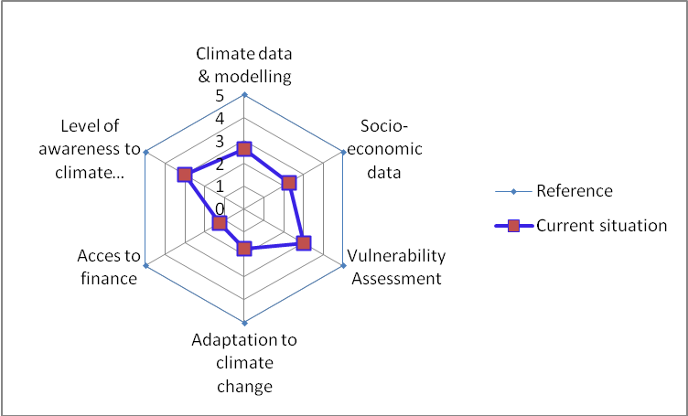

3.8 Targets for improvement of the current situation
Referring to the analysis, the strengths and weak points detected, we have identified the following gaps and opportunities for improvement. Taking into consideration the nature of the project (regional character, capacities building,) as well the means available, we propose the following realistic targets (see Figure 8).
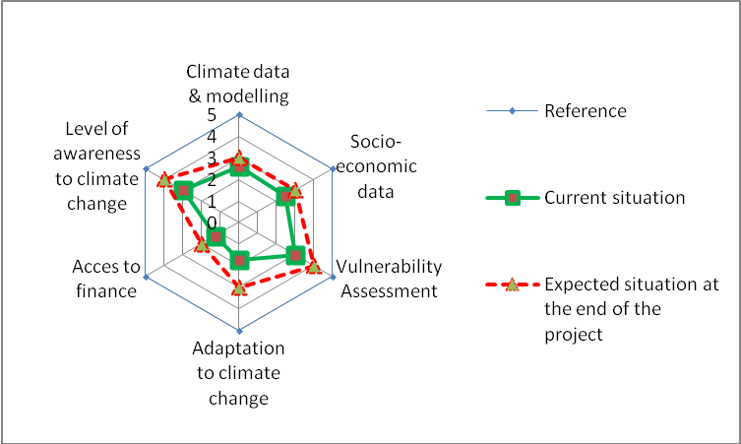
Figure (8) Assessment of a resilience target versus current rating

- Regarding climate data and climate modeling:
Weather/climate data and information are not available for free. Their costs represent a real challenge for their use at national level by all partners. Regarding data modelling, sharing among partners is insignificant. Similarly, socioeconomic data are characterized by a lack of access and open use between partners. Globally, the LMD has no visibility at the national level. The project CLIMA SOUTH is expected to strengthen the technical capacity of this institution and support it to play a more active role in addressing climate change issue at the national level. In fact, the main challenge is the lack of a culture/tradition for the exchange/sharing of information. A national dialogue is needed to clarify the issue and identify ways to overcome this important data exchange bottleneck, and the CCCUnit entry into operation with the NCE political blessing should improve the present situation.
- Socio-economic data in relation to climate change.
The project can provide support to improve the collection and the availability of data. On the other hand, knowing that sharing and use of data are more cultural and traditional issues, the project may initiate a national dialogue to address these non-technical barriers.

- Vulnerability Assessment
The project can provide support and tools to update and deepen the current assessments of vulnerability through.

- Adaptation to climate change:
The project can provide support to the current initiatives of adaptation to CC measures. In the other hand, the project must be consistent with the new cross cutting adaptation to CC approach based on the assessment of the vulnerability on food security, social development and poverty (new approach adopted for the third national communication of Lebanon).

- Access to adaptation to climate change financing:
It is really a new issue and the project need to start with information and training of the pre-identified stakeholders and very well targeted and stable human resources.

- Level of awareness of stakeholders to adaptation to CC:
This will be discussed within the component related to communication.

4.The communication and visibility issue
This ongoing working report represents a first analysis to be used for the refinement of the objectives of a realistic strategic communication plan. Such a plan should equally satisfy the various needs and expectations of the stakeholders involved in the project and the final beneficiaries in the South Countries. A general survey was conducted including:
- The analysis of documents and objectives;
- The detection of main target groups;
- The choice of recipients of the communication strategy;
- The definition of problems, potentials and decision on the strategic approach;
- The definition of primary issues to focus on.

- Meetings with resource people/stakeholders (see Annex 1 List of Interviewed stakeholders) aiming at understanding perceptions and at collecting suggestions and opinions. Main elements of discussion included:
- Needs and priorities and expectation in the field of communication to set the objectives;
- Identification of key target group and consequent ranking to their importance and influence relative to the communication objectives/activities;
- The final beneficiaries’ need and perceptions;
- The kind of media to involve in order to help to raise awareness among key target groups and to assure a media coverage for events /or information campaigns in the countries and during the UNFCCC COP events;
- Identification of potential synergies and possibility for joint actions;
- The objectives to achieve and the strategies to be followed to reach such objectives;

- Data Collection: gathering and analysis of reports, documentation, web sites and all relevant information were carried out in Beirut in order to identify and define the issues and potentialities of the communication plan development in Lebanon.

4.1Findings for Lebanon
The first learning phase, currently in progress, provided the consultant with a partial vision of the most important problems related to communication on climate change. The following issues are crucial:
- Exceptfor the Ministry of Environment and The Ministry of Agriculture, all other policy makers are not aware of the importance to integrate climate change adaptation and mitigation into a sustainable development policy;
- Some initiatives were carried out in connection with low carbon development projects such as the launching of the ‘Save Energy” campaign by the Lebanese Center for Energy Conservation Project (LCECP)a joint collaborative project between the United Nations Development Programme (UNDP) and the Ministry of Energy and Water (MEW). This campaign is aimed to generate public awareness on the cost-effectiveness and benefits of energy conservation and energy efficiency use. The campaign was targeting the general public, involved all media. A series of funny television spots played by a very popular actress in Lebanon, have been very successful and gave good results in the field of energy saving. The campaign has also involved schools through specific programs.

- There is, in general, a sort of “skepticism” about the subject of climate change, seen to be a fashionable issue for "rich people" and certainly far from being considered as a tool to improve the country's economic problems and quality of life;
- In addition, Lebanon is still politically fragile state, and all the energies of politicians, media and general public are focused on the political and economic problems;
- Usually, the language used by the researchers or National / International Institutes on climate change is difficult to understand. Many politicians, who are not specialized in the climate issues, as well as journalists find it extremely difficult to convert these terms or topics into clear, easily understandable for every one through media articles or political messages;
- All this leads to confusion and misunderstanding and does certainly not contribute to include climate change adaptation into other day to day problem-solving policies;
- NGOs are present in the area and some of them work with the Ministry of Environment. It is true, though, that their awareness campaigns deal with environmental problems but are hardly related or linked to climate change;
- AFED, a large NGO covering many Arab countries, has a very well organized website, a monthly magazine, and counts Saudi Arabia among its members. Every year AFED organizes a large event to launch a publication on various environmental issues. The event as well as the publication are targeted to AFED members and address a rather specialized audience, with a fairly straightforward language. For this reason it should be better studied and analyzed.
- Some newspapers such as the “L’Orient du Jour”or "El Nahar" and “Eldjoumhouria”,“Assafir” and “Al Akhbar” are used to publish monthly inserts dedicated to the environment, but even in this media, it is extremely rare to find issues related or linked to climate change; given the political and economic situation, the Editor in Chief of newspapers usually gives more importance to the country’s political issues.

4.2Targeted audience in Lebanon
From this initial survey in Lebanon, it is obvious that all issues related to climate change have not been taken into account appropriately. Climate change and the problems related to it are seen as an entity in its own right and are not seen as an integral part of sustainable development. This vision is perceived at all levels: from policy makers, to the educated and averagely informed people. It is nevertheless obvious, though, that target groups should be given the priority. For this - in Lebanon, so far, we have identified the following main target groups, recipients of the communication strategy.
  - Politicians and Parliamentarians;
  - Private sector;
  - Radio / TV Journalists

5. Conclusions
The tow graphs below ( representing a summary drawn from the Key Expert’s analysis discussed in theprevious sections) translate the Clima South team”integrated judgment” about the current situation compared to a reference target of 5, and possible improvements by the end of the project for each main focus.

These suggested final targets are relatively modest for both focus (low carbon development and resilience to climate change) but to our expert jugement they seem quite realistic in the current context and certainly we should be able to deliver them allHence most of the needed activities to reach these targets are proposed in the final work programmes.

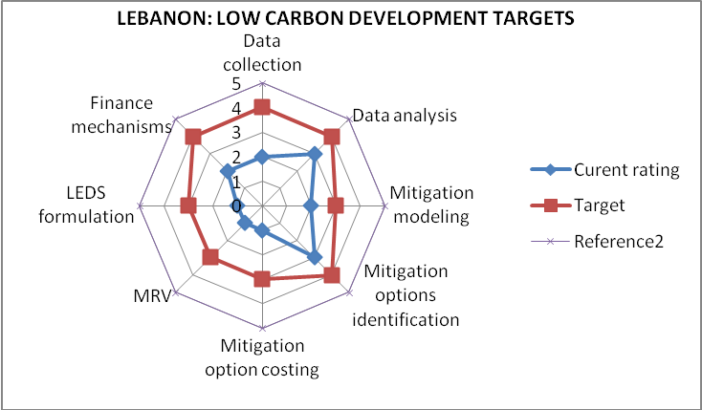

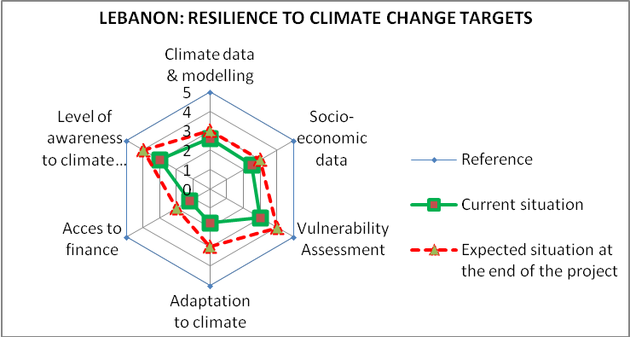
These methodologies for the analysis of the present situation, the needs assessment and the identifications of ways and means to achieve the set targets, should be discussed with the Clima South Focal Points at the country level and may be at the subregional and Regional Level before the discussion and final validation at the Programme Steering Committee Level.
The discussions at the country level will be done through email and phone and Skype conference calls, after sending the draft country assessment reports by email to the respective focal points fulfilling their individual request made after each country consultation. These second step virtual consultation process will insure the adequate and responsible contribution from each party, in order to create a win-win-win working environment for the speedy implementation of the shared objectives and the proposed activities;

Annex1: List of Interviewed stakeholders

Name | Institution/Job title | Phone number | Adresse | Email
Al Kantar Bassam | Al-Akbar Newspaper  Journalist | 01 759597 03350956; |  | bassam.kantar@gmail.com
Al sayegh  Mey | Al Joumhourya External Relations officer /writer & news editor | +961 1888051,Ext231  03 229 352 |  | Mey.sayegh@aljoumhouria.com  Mey.sayegh@gmail.com
CHAAR Ali | Lebanese Meteorological Department (LMD) | +961 1 628 000 | AirportBeirut  Lebanon | ashaar@beirutairport.gov.lb
Chouchani  Cherfane  Carole | United Nations  ESCWA Chief, water  resources section | +961 1 978 518  +961 1 981 510  + 961 3 769 466 | P.O.Box:118575,  United Nations House, Beirut-Lebanon | chouchanicherfane@un.org
Baaklini  Susan | Journalist, L’Orient Le Jour Newspaper.com | 03363811 |  | suzannebaaklini@lorientlejour.com
El Hajj  Dr.Rana | American University of Beirut (AUB) Program coordinator, climate change & environment in the Arab World | +961 1 350 000  Ext 4138  +9611 737 627  + 9613 404 625 | Issam Fares Institute for Public Policy & International Affairs,PO Box 11-0236,Riad El Solh 1107 2020,Beirut,Lebanon | re15@aub.edu.lb  www.aub.edu.lb/ifi
El Hajjar Khalil | ActiveWeb  Managing Director | +9611201617 |  | E.Khaiiar@activeweb.me  website: www.activeweb.me
EL Khoury  Nazem | Minister MoE | +961 1 976 533  +961 1 976 535 | P.O.Box: 11-2727, Beirut-Lebanon | nazem.khoury@moe.gov.lb  nazem.khoury@gmail.com
El Sheikh  Rola | MoE, service of technology & Environment, Head department of air quality | + 961 1 976 555 ext434  + 961 1 976 530 | Lazariehblgd,  PO Box 11-2727,Beirut,  Lebanon | rola.sh@moe.gov.lb  www.moe.gov.lb
el-Fadel Mutasem | Professor, Chairman at the American University of Beirut Environment |  |  | mfadel@aub.edu.lb
Geha  Dr.Mounah | Master Plan  General Director | +961 6 930 886/7  + 961 809 468  +9613 302 188 | P.O.Box 13 5247 | geha@cyberia.net.lb  geha@lynx.net.lb
Haddad  Raghida | AFED, Environment &  Development Chief editor  executive | +961 1 321 800 | EshmounBldg,  Rue damas,DT Beirut | www.mectat.com.lb  raghida@mectat.com.lb
Hajj Hassan  Dr.Salah | MoA  Consultant to  the Minister | +961 1 821 300/900  +961 03 741 899 |  | shajjhassan@agriculture.gov.lb  mmlebanon@hotmail.com
Hajj Shehade  Nader | Lebanese center for energy conservation (LCEC)  Energy engineer | +961 1 565 108  569 102  + 961 70 153 119 | MoEW,corniche du Fleuve,1st floor,room 303,Beirut,Lebanon | nader.hajjshehade@lcep.org.lb  www.lcep.org.lb
HarajliHassan | UNDP Project Manager  Energy & environment Programme | +961)1 981 944  +961)71 222555 | Maaradst,Bldg.287B,1st Floor,Beirut-Lebanon | Hassan.harajli@undp-lebprojects.org  www.cedro-undp.org
HŐfs Silke | EU Delegation in LebanonAttachée Communication & Culture officer | +961 1 569400  Ext 204 | 490 Harbor Drive Buidling  Charles Helou Avenue, Saifi, Beirut | silke.hofs@eeas.europa.eu
Jawhary  Dalia | Society for the Protection of Nature in Lebanon (SPNL) | +961 1 748 309  +961 1 344 814 | Hamra,  Abdel Aziz Street,  Awad Bldg,6th floor, Beirut, Lebanon | djawhary@spnl.org  Dalia.Jawhary@gmail.com
Jomaa  Ihab,PhD | Lebanese agricultural  research institute L.A.R.I  Head of department  of irrigation and  agrometeorology | +961 8 900 037/047  + 961 8 900 077  +961 70 09 97 41 | Tal Amara, Bekaa,Lebanon  P.O.Box 287-Zahle | Ijomaa@lari.gov.lb  www.lari.gov.lb
Kabakian  Vahakn | UNDP  Climate change advisor  Institutional support to MoE Project | +961 1 976555  Ext 475  + 961 1 981 534  +961 3 527 679 | MoE, DT Beirut, Lazarieh Center | vahakn@moe.gov.lb
KAI Lea | Adaptation expert, Project Manager (Third National Communication to the UNFCCC) | +961 1 976555 | MoE, DT Beirut, Lazarieh Center | l.kai@moe.gov.lb
KhayatZiad | Lebanese Center for Water Management& Conservation  project manager (groundwater assessment & database project) | +961 1 565 089  +961 1 565 090  +961 3 387 771 | MoEW,  Corniche du Fleuve,  Ground floor,  Beirut, Lebanon | ziad.khayet@undp-lebprojects.org
KhazenRola | UNDP  Senior Marketing Advisor energy&environmentprogramme | +961 1 981 944 | Maarad ST,Bldg.287B,1st Floor,Beirut-Lebanon | rola.khazen@undp-lebprojects.org
Maalouf Habib | Journalist, Safir newspaper | 03-363811; |  | hmaalouf@assafir.com
Makdisi  KarimPhD | AUB American University of Beirut Associate Director,Issam Fares Institute Associate Professor, Dept. of Political Studies  & public administration | +961 1 350 000  Ext 4150/2  + 961 1 737 627 | PO Box 11-0236,Riad  El Solh 1107 2020,Beirut  Lebanon | Karim.Makdisi@aub.edu.lb  www.aub.edu.lb/ifi
Masri  Nour | UNDP  Project Manager, Environmental resources monitoring | + 961 1 976 555  ext445  + 961 3 693 078 | MoE,Lazariehblgd,  Block 2,  Floor 8,Room 8-21,  PO Box 11-2727,Beirut,  Lebanon | nour.masri@undp-lebprojects.org  n.masri@moe.gov.lb
Mohanna H.  PhDChadi | MoA, Rural development and Natural Resources  Director | +9611 848 447 | Jnah, Lebanon | iopgov@cyberia.net.lb
Moumen  Dr.Ali | FAO  Representative  in Lebanon | +961 5 924 005/6/7  +961 5 922 128 | B.P.40010 Baabda  Lebanon | fao-lb@fao.org  ali.moumen@fao.org
Ritzenthaler Nicolas  Bewaleyne Cyril | Delegation of the European Union to the Republic of Lebanon  Environmental & Sustainable Development Division | +961 1 569400 | 490 Harbor Drive Buidling  Charles Helou Avenue, Saifi, Beirut | delegation-lebanon@eeas.europa.eu
Mousallem  Manal | UNDP  Project Manager, institutional support to MoE | +961 1 981 854  + 961 1 982 391 | MoE, DT Beirut,Lazariehcenter,Block 02A,8th Floor,Office 8-8 | manal.mousallem@undp-lebprojects.org
SAAB Najib | Executive Director of Arab Forum for Environment and Development (AFED) | 01-321800 | Eshmoun Bldg.  Rue Damas DT Beirut | www.najibsaab.com  info@afedonline.org  www.afedonline.org
Sadek M.Tarek | United Nations  ESCWA  Water & Environment  Officer | +961 1 978 520  +961 1 981 510  +961 70 824 432 | P.O.Box:118575- Beirut-Lebanon | sadek@un.org  www.escwa.org.lb
Sayah  Ghassan | MoE  Senior Advisor | + 961 1 976 517  + 961 1 976 535 |  | ghassansayah@hotmail.com
Tawk  Salwa | Vice-president Mada Foundation | +961 3 063 177  +961 1 380 437 | Etienne Atallah Bld.,  2rd floor, 20 Al Arid str, Ain El Remaneh,  Beirut, Lebanon | mada@mada.org.lb
WEHAIBE Marc | Lebanese Meteorological Department (LMD), Director | +961 1 628 000 | Airport Building  Beirut Lebanon | wehaibem@beirutairport.gov.lb

Annex 2: Documentation collected& reviewed

- Climate Smart Agriculture: Enhancing Adaptative Capacity of the Rural Communities in Lebanon (AgriCAL), Ministry of Agriculture, IFAD Agriculture 7860825, July 2012.
- The National Economic Environment and Development Studies (NEEDS) for climate change project (Ministry of Environment, Issam Fares Institute of Public Policy and International Affairs, American University of Beirut and UNFCCC) January 2011. (45 pages)
- Lebanon, Technology Needs Assessment for Climate change, Republic of Lebanon, UNEP GEF in collaboration with UNDP, December 2012. (230 pages)
- The Residential Solar Water Heaters Market in Lebanon in 2011, Ministry of Energy and Water, Lebanese Center of Energy Conservation (LCEC), September 2012 (55 pages)
- The National Energy Efficiency Action Plan for Lebanon NEEAP (LCEC) 2011-2015, LCEC, February 2012 (54 pages)
- Arab Environment Climate Change Impact of Climate Change on Arab Countries, Executive Recommendations, AFED, 2009 (18 pages).
- State and Trends of the Lebanese Environment 2010, Ministry of Environment & UNDP (355 pages)
- Act N° 481 Dated 12 December 2002 on the Establishment of the Civil Aviation Authority, including Meteorological Services
- Saving Energy, Official Publication of the Lebanese Center for Energy Conservation (UNDP), August 2011
- CEDRO Newsletter, Issues n° 6 & 7 Country Energy Efficiency and Renewable Energy Demonstration Project for the Recovery of Lebanon
- LCEC Summary Note 01, The Lebanese national CO2 emission factor: How clean is the electricity we produce?
- LCEC Summary Note 02, Net metering in Lebanon: Reduce your energy bill through Green Energy Production
- LECE Summary Note 04, NEERA: A financing mechanism for Renewable energy and energy efficiency
- LCEC Briefing Note 02 , The 3 million compact fluorescent lights project in Lebanon
- Economic and Social fund for Development (SFD), Newsletter, Ten Years of Commitment to Social Development in Lebanon, June 2012
- Inventory of Shared Water Resources in Western Asia, Federal Institute for Geosciences and Natural Resources, ESCWA, 2012
- Assessing the Impact of Climate Change on Water Resources and Socio-Economic Vulnerability in the ESCWA Region: A methodological Framework for Pursuing an Integrated Assessment, UN ESCWA. (88 pages)
- Arab Environment, Survival Options, Ecological Footprint of Arab countries, Arab Forum for Environment and Development ADED (1921-2012)
- Arab Forum for Environment & Development, Help build a Green future, (AFED) 2012.
- The Second National Communication National (SNC) under UNFCCC
- EU report on the Climate Change Risk Assessment in the Arab countries (Country profile of Lebanon),
- Capacity Self‐Assessment (NCSA) Cross‐cutting Synthesis Report: Lebanon, October 2007
- Global Environment Facility (GEF) (2005). National Capacity Self‐Assessment (NCSA), “Resource, Kit” (GEF/UNDP/UNEP, New York, September 2005)
- "Climate Change, Water and the Policy Making Process in the Levant and North Africa", The Research and Policy Forum on Climate Change and Environment in the Arab World at the Issam Fares Institute for Public Policy and International Affairs, AUB (Beirut), AUB, August 4, 2009.

Annex 3: List of on-going projects
Cooperation projects
EU - Lebanon: EU (DG ENER program) project Energy Policy Dialogue: bilateral project between the European commission and the Lebanese government.
EU-Lebanon: Agriculture &Rural Development Programme (ARDP), 2011-2015,(14MEuro),implemented by the Ministry of Agriculture with technical support from a consortium led by Agriconsulting, with a component on Risk Transfert and Climate Risk Management for the Rural Communities, through a Mutual Fund for Disaster including those amplified by a Changing Climate.
EU Member States/Lebanon
- Country Energy Efficiency and Renewable Energy Demonstration Project for the Recover of Lebanon (CEDRO) Spanish government/UNDP;
- National Energy Efficiency and Renewable Energy Action - by LCEC (NEEREA) provided by the EU as a grant ;
- Climate Change Mitigation Project is a collaborative initiative between the Italian Cooperation and the Ministry of Environment;
- Sustainable Energy Action Plans EU-ENPI. The budget is 4 Million Euros for 10 countries, and the project length is 3 years;
- The EIB / AFD joint project entitled "Lebanon Energy Efficiency and Renewable Energy Project";
- Low Emission Capacity Building Project, funded by EC, the German Federal Government and the Australian Government;
- ADEME (France) with whom the Lebanese Association for Energy Saving and for Environment an agreement of cooperation in the energy and environment fields: DSM project in Zouk / Byblos (Jbeil), educational project « Libanprecieux - planeteprecieuse », energy efficiency in transport, etc;
- French GEF framework project PEEC: Energy Efficiency in building in Lebanon;
- MEDA regional project with the consortium DECON (Germany), BCEOM (France), CEETA (Portugal) and ENERCO (Italy) Reform of the Legal and Institutional Energy Sector in Lebanon.
- Lebanese Cleaner Production Center (LCPC) (UNIDO), Austrian government/LIFE Programme (EC-LEFE)
Other donors projects
GEF Projects:
- Lebanese Center for Energy Conservation (LCEC) 2002 UNDP /Global Environmental Facility (GEF/UNDP)
- Second National Communication (SNC) (GEF/UNDP/MoE)
- The National Energy Efficiency Action Plan for Lebanon (NEEAP) LCEC/CEDRO GEF/ UNDP
- Technology Needs Assessment - Round II (UNEP/UNDP/MoE).
- Third National Communication (TNC) (UNDP/MoE)
- UNDP/GEF funded Solar Water Heating Project as a part of the Global Solar Water Heating Market Transformation and Strengthening Initiative
- Photovoltaic with MOEW & UNDP ($1.4 with GEF funding)
- Sustainable Energy for All (SE4ALL) initiative launched by the United Nations Secretary-General
- UNEP’s Enlighten Initiative
- Introduction and use of Renewable Energy in Arab Salim - Project Co-funded with THE LEBANESE SOLAR ENERGY SOCIETY - LSES (Non-government Organization). Construction of three renewable energy stations with different modules; which starts from solar heaters and relating it to the energy produced by the air fans which produces hot water all over the year to relating the new central heating systems to the heaters and consequently reducing the usage of diesel in the area of Eqlim el Tofah in the south of Lebanon.
- Formulation of policies on CC, granted by the Lebanese committee for environment and development, granted by the Lebanese committee for environment and development. The project aims at raising awareness, networking, reviewing policies and disseminating information in the area of climate change and renewable energy among all concerned bodies.
- Combating desertification and improving green cover at Fakeha Al Ain village (pilot phase).
- METAP program of the World bank related to the environment issues in Lebanon: air, water and waste.
Adaptation Fund
- Climate Smart Agriculture: Enhancing Adaptative Capacity of the Rural Communities in Lebanon (AgriCAL), Ministry of Agriculture, IFAD Agriculture (ongoing)
Involvement of Lebanon in regional projects
- ENPI Clima South Program: Support Climate Action in ENPI south countries (2013-2017)
- An EU funded MED-Solar project in the frame of ENPI program (Cross-Border Co-operation in the Mediterranean)
- Paving the Way for the Mediterranean Solar Plan (PWMSP) is an EU funded regional project assisting the Mediterranean Partner Countries to contribute to a significant increase in deployment of sustainable energy systems based on renewable energy sources.
- EU (INCO) project: REACT: Self-Sufficient Renewable Energy Air-Conditioning Systems for MPC. Web address: www.crear.unifi.it/react;
- EU (INCO) project: RAMSES Renewable Energy Agricultural Multipurpose System for Farmers
- EU (INCO) project: HYPA Euro-Mediterranean renewable energy partnership. Web address: www.hy-pa.org
- EU (INCO) project: SOLATERM Promotion of a New Generation of Solar ; Thermal Systems in the MPC. Web address: http://ioffice.gtz.de/solaterm ;
- EU (INCO) project: SOLAR BUILD Integration of Solar Technologies into Buildings in Mediterranean Communities;
- EU (SMAP program) MED-ENEC: Promoting Energy Efficiency in the Construction Sector;
- MED-ENEC II - Energy efficiency in construction: Encourages energy efficiency and the use of solar energy in the construction sector, through capacity building, fiscal and economic instruments and pilot projects (Algeria, Egypt, Israel, Jordan, Lebanon, Morocco, Occupied Palestinian Territory, Syria, Tunisia, and Turkey).
- EU (MEDA program) regional project with the MEDENER network ASTEMB: Application of Thermal Solar Energy in the Mediterranean Basin. Web address: www.solarmed.net.
- EU (synergy program) regional project with IDAE (Spain) Energy and Urban Environment in the Mediterranean Countries.
- EU (INCO program) project: SUSTENMED: Dissemination of Sustainable Energy Technologies in the Mediterranean Basin.
- EU (ENPI-South,EuropAid) Project CES-MED 2013-2015, “Cleaner Energy Saving Mediterranean Cities”, with the regional Office possibly implemented in Beirut in the coming months
- UNESCWA and others ( with financial support from Sweden & Germany) 2009-2015,Projet on Regional Assessment for the Impact of Climate Change on Water Resources and Socio-Economic Vulnerability in the Arab Region (RICCAR). This Climate Variability and Change Services for the water sector works for capacity building of all the ENPI CLIMA South Countries and Beyond

Annex 4: List of possible activities
Updated propositions from the EU country profile
- Public awareness raising – information campaigns, in particular training activities for decision makers, with the view to making climate change a political priority and to facilitate the development of a strategic and long term approach to climate policy
- Support to NGOs active in the fight against climate change, and promote cooperation among NGOs in the region (oPT, Jordan, Lebanon, Egypt)
- Assistance on CC governance: Strengthen institutional capacity on climate change through the establishment of a Climate Change Coordination Unit working under the authority of the Minister for Environment and Coordinated through the National Council for Environment(NCE), for the design of strategic planning tools for mitigation (capacity to elaborate a national Low Emission Development Strategy) and Climate Resilience in every socio-economic sector of importance and impacted by a changing Climate
- Support economic assessment of mitigation and adaptation options (“the Stern report for Lebanon” according to the Ministry of Environment)
- Support the elaboration of sectoral adaptation strategies (ICZM, tourism, fisheries, agriculture) and integrate them into the sectoral strategies to ensure the mainstraiming of CC issues in the chalenges of each sector
- Build MRV capacity, in particular for the quality improvement of national inventories (data collection and quality control procedures for accuracy)

Proposals emerging after country mission and subsequent consultations with the Focal Point & Partners

- Contribute to the Conception and Implementation of An Integrated Early Warning and Advisory Climate Service (Lebanon IEWACS) to cope with the effects of CC induced extreme weather and water phenomena (such as Drought, Floods, Heat Waves, Forest Fires etc.) as well as enhance mitigation and response mechanisms through an effective and sustained climate & vulnerability monitoring and early warning systems.

- Support the ongoing Lebanese Agricultural Research Institute (LARI) early warning system to increase farmer’s resilience to CC through i) the improvement of the appropriate climate information provided, ii) the assess the socio-economic impacts of this experience and iii) the scaling up of the advisory systems and climate services to other agriculture production systems and rural communities impacted by /coping with climatic and hydrologic hazards.

- Support and identify ways and mean to sustain financially the Lebanese Meteorological Institute and strengthen its technical capacities and skills to enable it to play a more active role in addressing climate change issue at the national level and for every impacted socio-economic sector, through appropriate weather-water & climate Services. The sustainability of the Climate Information & Services process will look for making this vital knowledge accessible to every institution or individual in need of.

- Support the development of baseline CC projections over Lebanon and seasonal to annual climate prediction. This climate knowledge is to be shared with all stakeholders in order to improve the vulnerability assessment and the implementation of adaptation measures to CC and support the strategic planning of a low carbon economy.

- Contribution to the implementation (getting operational) of the Climate Change Coordination unit, as an integrator for Mainstreaming Climate Action in Socio-Economic Activities, and performing the Secretariat of the National Council for Environment. This will be done through Capacity building of every member of the NCE (7 Public Entities & 7 Private, Civil Society Organisation and Academia) at the Central and District Level. It could sustain the whole process of a proactive Risk Management by initiating/supporting a Curriculum at the University Level for Climate Risk and Opportunities Management, starting with Business and Planning Schools.

- Contribution to the Initiative led by the Ministry of Environment in Strengthening the capacity of the Ministry of Finance (National Budget, Public Banks/Mutual Funds, and Private Insurance Cies) to mainstream climate risk management in their strategy and support the sustainability of the early warning system (Investment and operation cost).

NB. The selection of the priority actions within the above list of specific activities will be done with the CLIMA South focal point , with the main objective to integrate the maximum in the regionally planned activities, then identify the ones of priority in national specific interest, with the view that every activity conducted within the CLIMA South Project , even starting at the local level , should be scaled up at the National , then Sub-regional to reach the Mediterranean level as a Good Practice in support to Low Carbon Development & Climate Resilience. This Process will go a long way in the construction of a Country fully owned Programme which will feed a nourished South-South exchange supported by a North South Partnership through twinning possibilities to be identified at the National and/institutional level.

A qualitative assessment is carried out by assigning a level to each analysis element state as follow: [1] Very low [2] Low [3] Average [4] Good [5] Very Good

