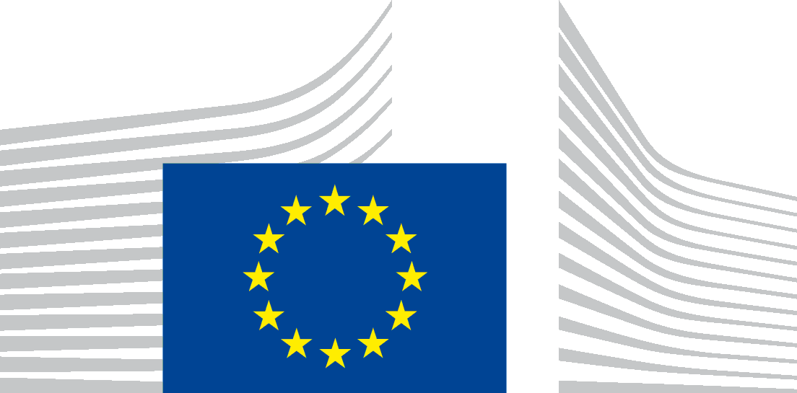 eeaszone

EUROPEAN COMMISSION

International Cooperation and Development

European Neighbourhood Policy and Enlargement Negotiations

**External Investment Plan – Regional Outreach Event**

**8th November 2017, 9h00-17h00**

**CAIRO**

**DRAFT AGENDA**

1. ***Registration*** *(9:00-9:30)*
2. ***Welcome and opening remarks*** *(9:30-10:00)*

*Ambassador Ivan Surkoš - Head of EU Delegation to Egypt*

*H.E. Sahar Nasr- Minster of Investment and International Co-operation (tbc)*

*H.E. Tarek Kabeel- Minister of Commerce and Industry (tbc)*

1. ***EIP: main features and innovations*** *(10:00– 10:45)*

*DG NEAR. European Commission*

***4. Session 1: Energy*** *(10:45- 12:15)*

*Climate change and lack of sustainable and reliable energy access exacerbate poverty, weaken development efforts and are among the root causes of migration. Limiting the global mean temperature rise to below 2°C would require around $3.5 trillion in energy-sector investments each year until 2050. The transformation of the energy sector also requires ambitious policy measures, as well as unlocking private capital, in particular from institutional investors, through risks mitigation. This session will focus on how the EIP can support the development of new climate resilient opportunities across the sustainable energy sector in the region.*

***Speakers***

* *Stéphanie Lanfranchi, Agence Française de Développement, Country Director, Egypt.*
* *Union for the Mediterranean*
* *EBRD (tbc)*
* *Siemens (tbc)*

***5. Coffee break***  *(12:15-12:45)*

***6. MSME – Access to finance and fostering innovation*** *(12:45-15:00)*

*Micro, Small and Medium Enterprises (MSMEs) are an essential component of local ecosystems in developing countries and they often represent the vast majority of businesses operating in the EU Neighbourhood countries; nevertheless their growth is constrained by limited possibilities of accessing affordable sources of financing, the lack of adequate technical, professional, financial and managerial skills as well as non-conducive legal and regulatory frameworks. Considering that a comprehensive range of instruments for general SME finance is already available under the Neighbourhood Investment Facility (NIF), this session will focus on how the EIP could promote instruments and facilities addressing unserved sub-sectors in the region in particular in the field of innovation, start-ups as well as digital entrepreneurs, social entrepreneurs, agri-business and the integration of MSMEs into value-chains.*

***Speakers***

* *Christophe Lucet , Regional Representative, European Investment Bank*
* *Carlos Conde, Head of Division, Middle East and Africa Division, OECD*
* *Ingrid Schwaiger, DG NEAR, European Commission*
* *FMO (tbc)*

***7. Closing remarks*** (15:00- 15:10)

***8. Late lunch and networking*** (15:10-17:00)